

American International University-Bangladesh (AIUB)
Department of Computer Science and Engineering
Faculty of Science &Technology (FST)
Spring 2024
CSC 00191- Object Oriented Analysis and Design (OOAD)
Section: H
Project Title: An eSports management system.

Submitted by: Group - 04
Name | ID
Md Arif Shahriar | 23-50159-1
Sudipta Kumar Das Prottay | 23-50164-1
Emon Biswas | 23-50174-1
Repha Tasneya | 23-50944-1

Submitted to:
MD. ANWARUL KABIR
Department of Computer Science
Associate Professor

eSports Management System: Enhancing Team and Event Administration through Technology

Overview:
The eSports Management System: Enhancing Team and Event Administration through Technology aims to revolutionize the eSports industry by providing a comprehensive platform that caters to both players and organizers. For individual players and teams, the system simplifies the process of discovering and participating in various tournaments. It offers a user-friendly interface where players can create profiles, track their progress, and easily find tournaments that match their skill level and interests.
For corporations and individuals looking to organize tournaments, the system handles the complexities of event management. It provides tools for scheduling, registration, and bracket creation, ensuring a smooth and professional tournament experience. Additionally, it manages broadcasting, allowing organizers to reach a wider audience through live streaming and recorded content.
The system also facilitates sponsorship acquisition by connecting organizers with potential sponsors and managing sponsorship deals. By handling these logistical aspects, the platform allows organizers to focus on creating engaging and memorable events.
This eSports Management System is designed to enhance the overall eSports experience by providing an all-in-one solution for tournament participation and organization. It supports the growth of the eSports community by making it easier for players to compete and for organizers to host successful events.

Justification:
The eSports Management System offers numerous benefits and addresses the needs of various users, making it an indispensable tool in the eSports industry. Here are seven key points highlighting its usefulness:
- Enhanced Tournament Discovery: Provides players and teams with an intuitive platform to easily find and register for tournaments, increasing participation opportunities and exposure to competitive play.
- Streamlined Event Management: Offers comprehensive tools for organizers to manage all aspects of tournament logistics, from scheduling and registration to bracket creation, ensuring smooth and efficient event execution.
- Efficient Broadcasting Capabilities: Facilitates live streaming and recording of events, allowing organizers to reach a global audience and enhance viewer engagement, ultimately increasing the visibility and popularity of tournaments.
- Simplified Sponsorship Acquisition: Connects organizers with potential sponsors and manages sponsorship deals, providing financial support and resources to enhance the quality and scale of events.
- Improved Player and Team Management: Enables players and teams to create and maintain profiles, track their progress, and manage their participation in various tournaments, fostering a more organized and professional approach to eSports.
- Increased Accessibility and Inclusivity: Provides a user-friendly platform that caters to all levels of players and organizers, promoting inclusivity and broadening the reach of eSports by making it accessible to a wider audience.
- Comprehensive Analytics and Insights: Offers detailed analytics and reporting tools that help players, teams, and organizers understand performance metrics, viewership data, and other critical insights, driving informed decision-making and continuous improvement.
Overall, the eSports Management System enhances the efficiency, accessibility, and quality of eSports tournaments and events, benefiting players, teams, and organizers alike. It supports the growth and development of the eSports community by providing essential tools and resources that streamline processes and elevate the overall experience.

Use Case Diagram:

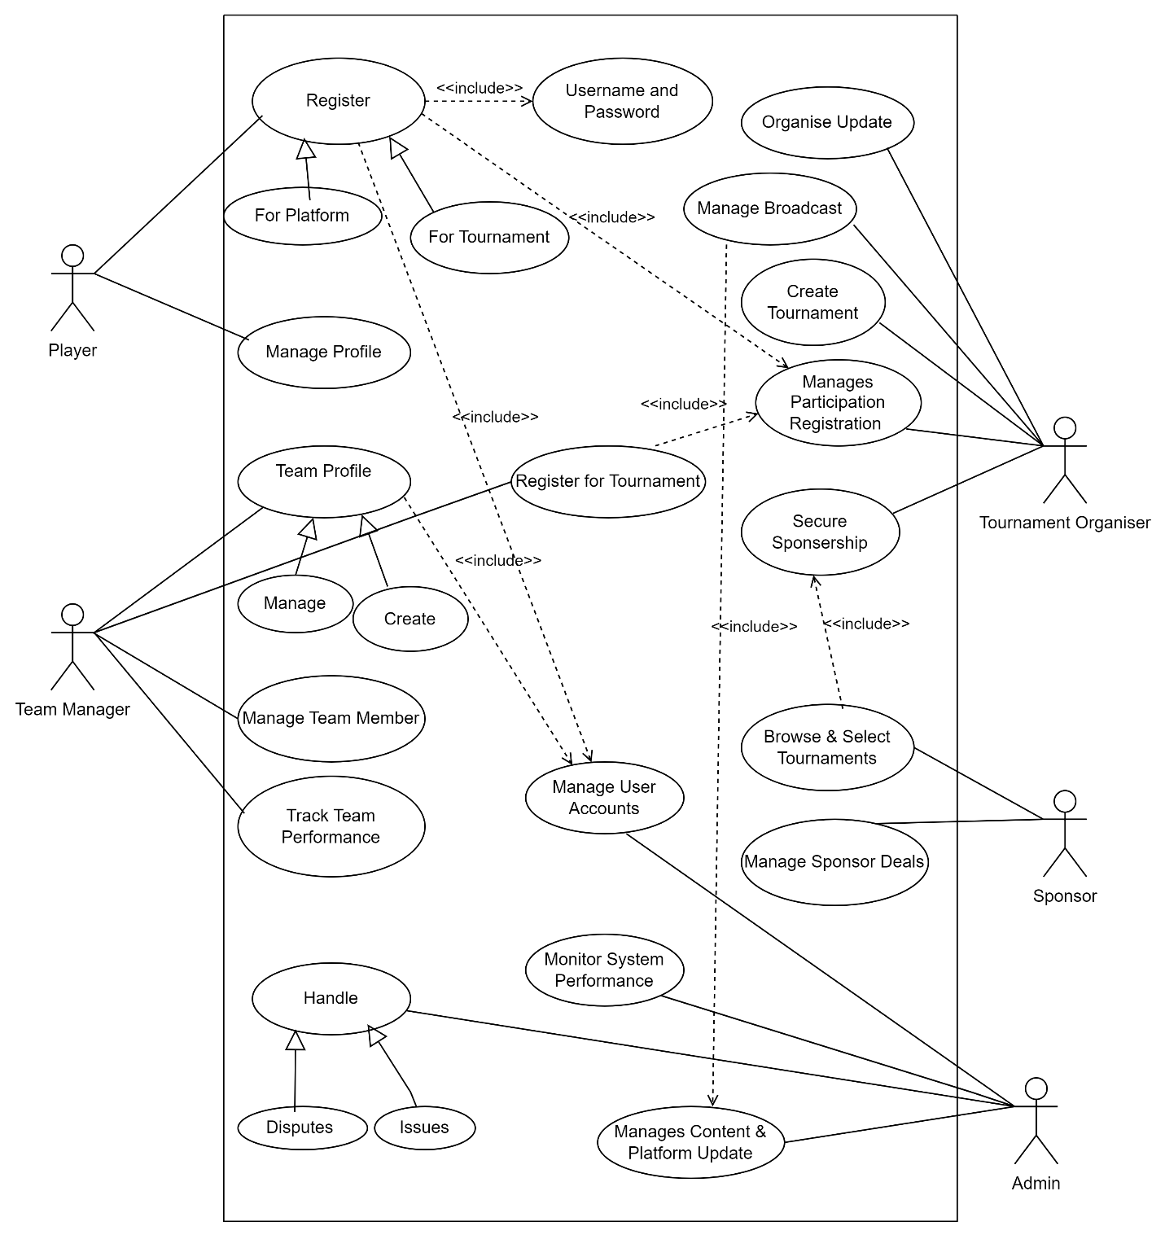

Components:

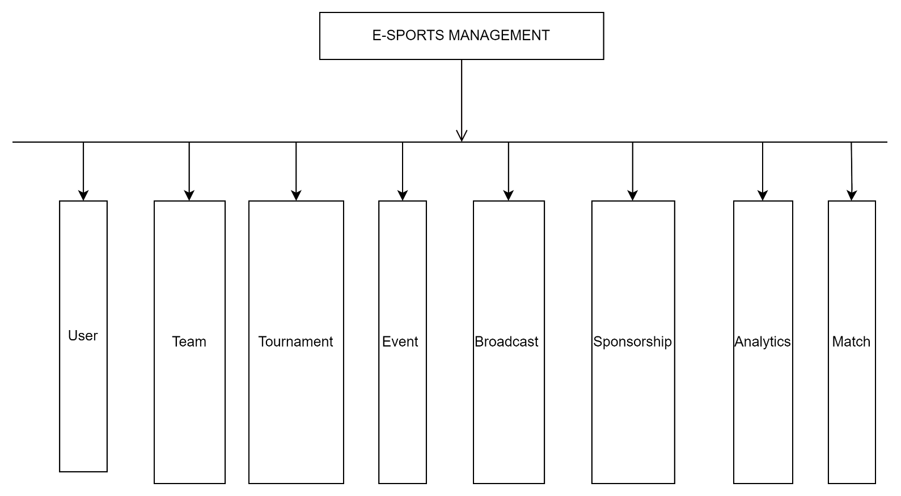

Class Diagram:

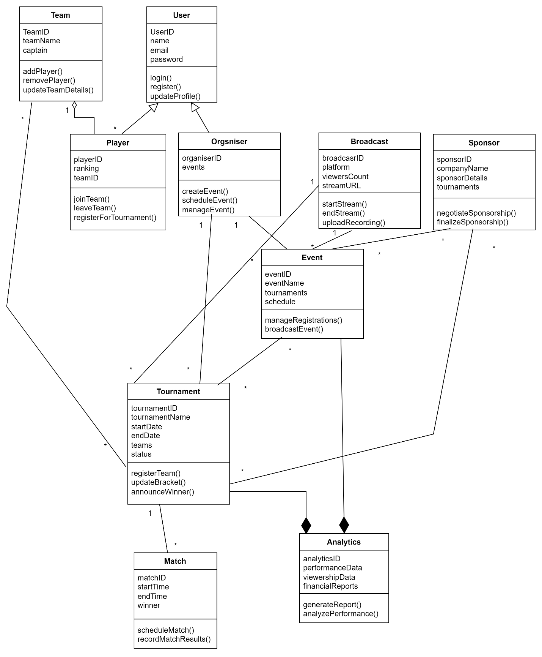
Activity Diagram:

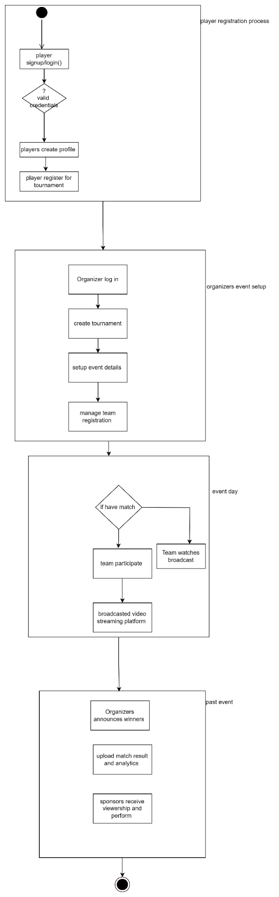
Sequence Diagram :

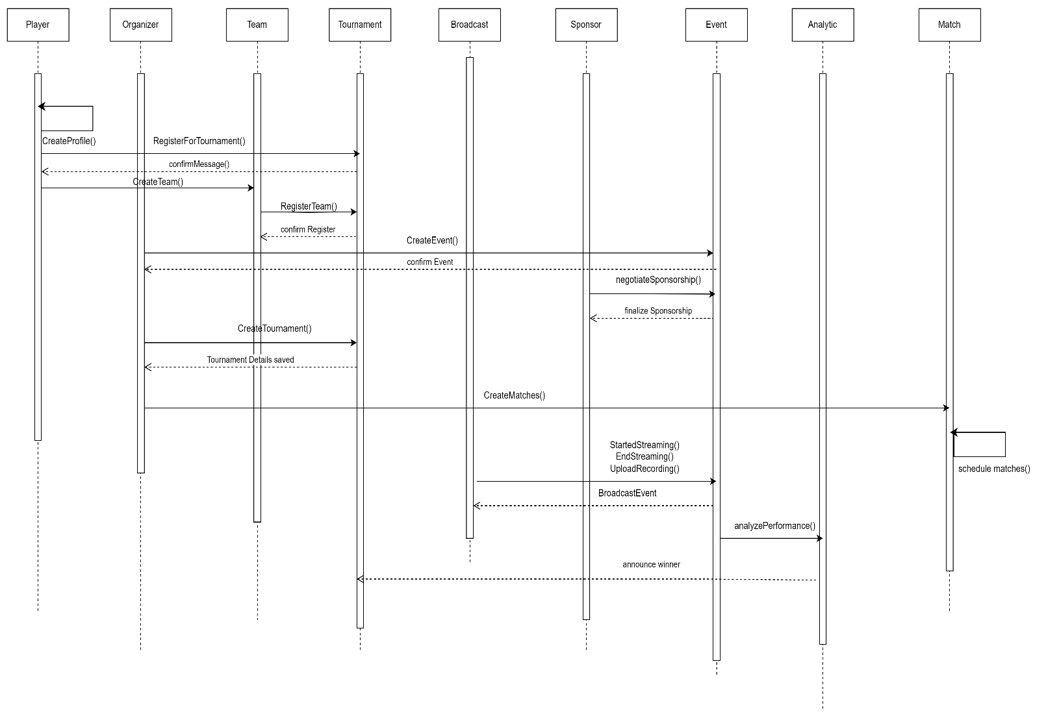

Statechart Diagram (Tournament):

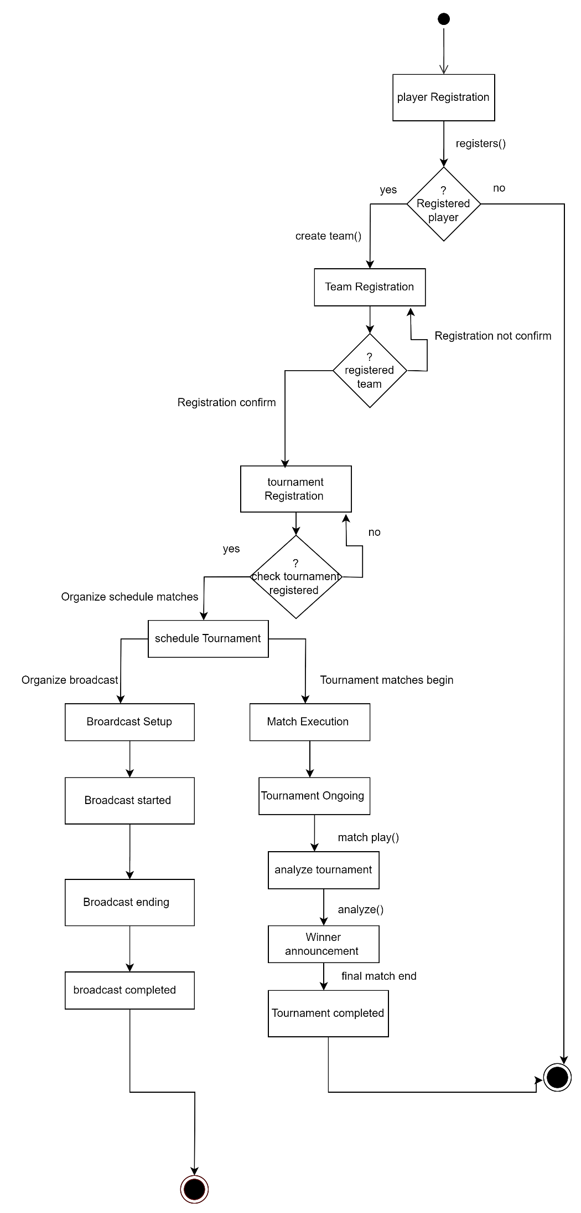
Conclusion:
The eSports Management System is designed to streamline and enhance the eSports ecosystem by providing an all-in-one solution for both players and event organizers. Through its intuitive platform, it simplifies team management, tournament participation, event organization, and sponsorship acquisition. Additionally, the system offers broadcasting tools and advanced analytics, promoting inclusivity and growth within the eSports community. By improving efficiency and accessibility, the eSports Management System fosters greater participation and supports the success of competitive gaming events, ultimately contributing to the development of the eSports industry.

